* Description of your project
* Pseudo code for algorithms and program flow
* Visual design template or example
* Brief description of how you will test your project

**Description:**

The new interface will include tab-based multiple view controllers, and will follow the layout of the ATLAS webpage. As this app will be an advancement of the previous atlas app, the functionalities of the previous app will be embedded into a tab of the new app.

The app introduces the ATLAS institute and programs and courses offered. The university provides an online web-based platform to provide the information. The app will facilitate students and staffs to get the brief description about ATLAS website.

**Pseudo code:**

* Create app Launcher - Colorado Boulder logo
* Main app storyboard:
  + Create Tab bar controller (three scene)
    - First scene –Introduction of the app
    - Two in-built view controller will have the ABOUT section and website of ATLAS homepage
  + Adding another view controller from the object library and creating buttons, label for -program, year, and term with flexible space bar and unwind segue method for exit
  + Again, one more view controller to ask questions about the ATLAS masters and PhD and provide a list of courses offered
    - Using UISegmentedControl (same as previous app)
    - Or Using dependent pickerview
  + If possible, add the list of people (making a plist) and group with table view grouped style in alphabetical order with their png pictures with UIImage
  + Connect the buttons to view controller.
  + For portrait and landscape orientation
* Connect delegate and sources.
* Apply the connections

The main screen

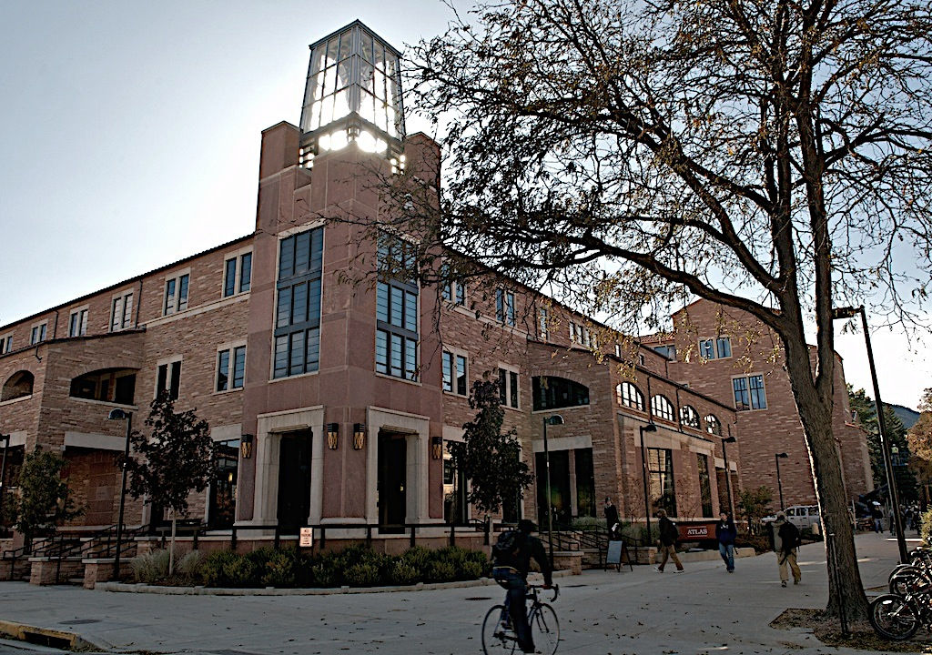

Text about the app

|  |  |  |  |
| --- | --- | --- | --- |
| About | Web | Admission | Speakers |

An example of the screen that will appear after clicking the web tab





Atlas page display

**Next 🡪**

**Visual Design template:**

Multi view app will somewhat look like this.





**Masters PHD**

**1st  2nd**

**Fall Spring**

**Program**

**Term**

**Next 🡪**

**Year**

**Admission**

**Testing the Project:**

* Image sizes for app icon
* Test for proper connection of buttons in connection inspector
* While making new file with Cocoa touch check the class
* Also check the subclass of view controller
* Test the navigational consistency so that information for each condition is displayed correctly.
* Adding constraints according to the requirement of the button and also updating the constraints
* While building check the deployment info and in deployment target always make it 8.0 and above
* If you build your app in xcode 6.1 and try running it in 6.0.1 then there might be an error with library files and it may crash too ☺